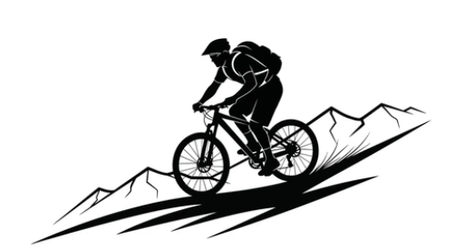

Camp Wakpominee – Mountain Bike Permission Slip

I, the undersigned give my child __________________________________________ who is _______years old, permission to participate in this program. I understand that participation in this activity involves physically demanding activities inherent to cross-country mountain biking including a certain degree of risk of injury. I have carefully considered the risk involved and have given consent for my child to participate in this activity. I understand that participation in this activity is entirely voluntary and requires participants to abide by the rules and standards of conduct set by the Twin Rivers Council. I release Scouting America, The Twin Rivers Council, the activity coordinators and all employees, volunteers and related parties associated with the activity from any and all claims of liability arising out of this participation. This release also authorizes transportation for the participant to any off-camp field trip associated with the mountain biking program.

For safety, my child and I agree that they will do the following or they will be removed from the program. I understand that any additional cost associated with the participation in this program will not be refunded if my child is removed for not following the rules below.
- Complete a course safety briefing
- Wear all safety equipment at all times while participating in the program
- Follow all safety rules provided in the briefing
- Follow the instructions of the course director’s while participating in the program
- Is 13 years of age as of the start of the class

Participant printed name____________________________________________

Participant signature _______________________________________________ Date ___________________

Parent / Guardian printed name _____________________________________

Parent / Guardian signature _________________________________________ Date ___________________

Contact phone # ________________________________ Alternate phone # ____________________________

Email address _____________________________________________________

